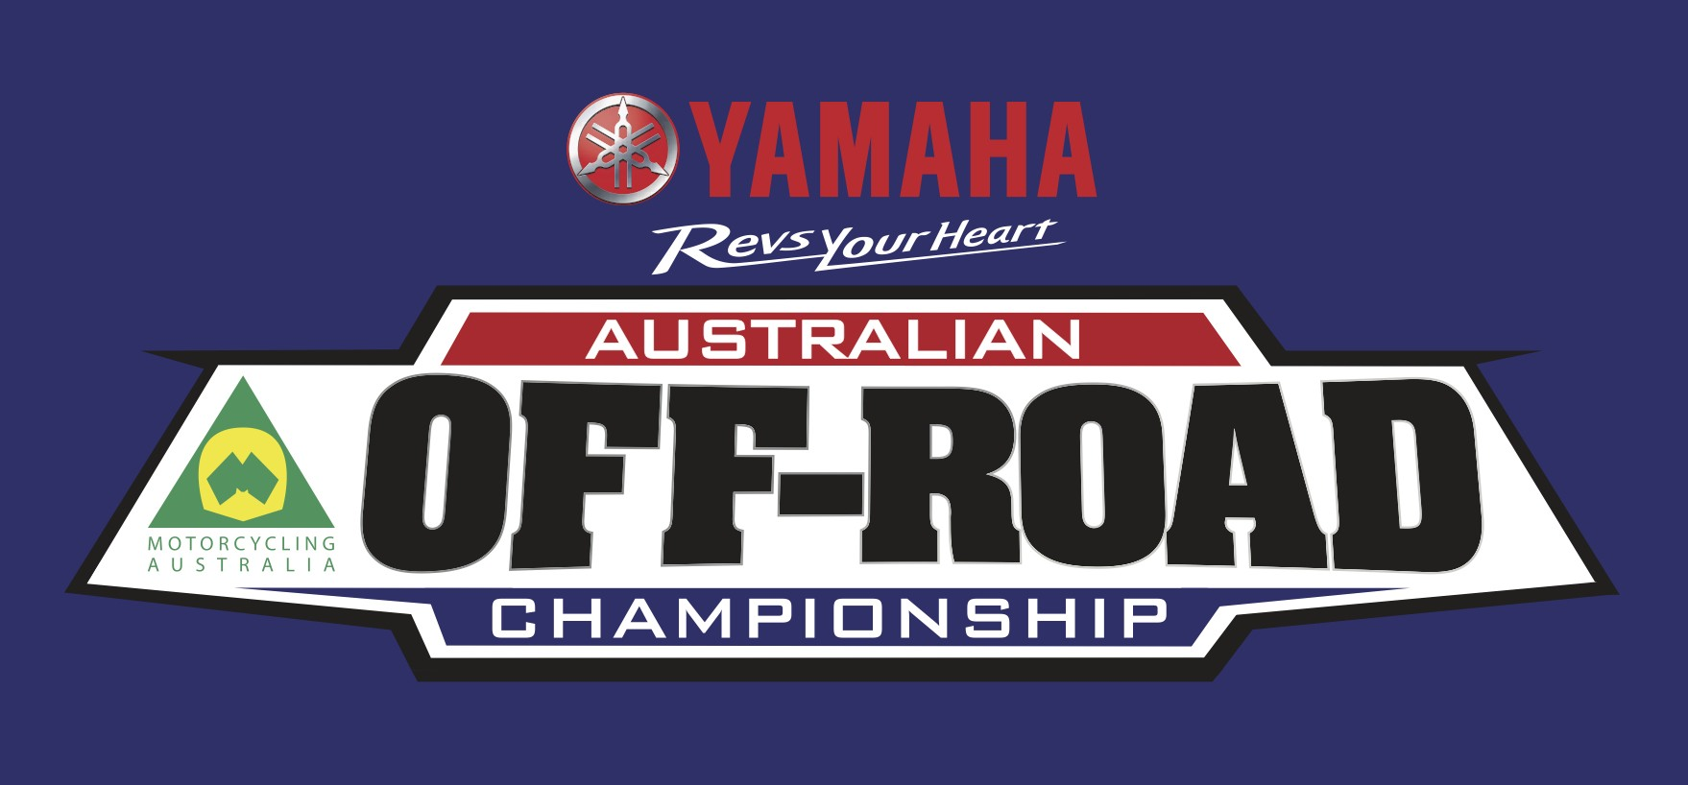

2018 Yamaha Australia Off-Road Championship Media Accreditation Request

Terms and Conditions:

Motorcycle racing is dangerous and persons attending motor racing events do so entirely at their own risk. It is a condition of this media accreditation that all persons having a connection with the promotion and/or conduct of the meeting, including the owners of the land, the riders, owners of the vehicles and the passengers in the vehicles are absolved from all liability arising out of accidents causing damage or personal injury except where due care and attention have not been exercised.

The accreditation pass remains the property of Motorcycling Australia and it can revoke accreditation at its discretion. Failure to follow instructions from race officials whilst on track will result in immediate revocation of your accreditation and ejection from the venue. Misconduct is taken seriously and in addition to revocation of your accreditation, inappropriate behaviour will be taken into consideration in future accreditation applications.

Lost accreditation must be reported immediately as the identification number must be cancelled and a new one will be issued at a charge of $30. Accredited vests provided by Motorcycling Australia must be worn when on the track and returned at the conclusion of each round attended, otherwise a replacement fee of $50 will be charged.

In the event of a serious incident all media will take direction from Motorcycling Australia staff, if you are asked to move away and not shoot the incident you will do so in a timely manner.

Accreditation Guidelines:
All accreditation will require pre-approval by Motorcycling Australia. There will be no commercial photo/film access unless agreed in writing by Motorcycling Australia.

Journalists –
Accreditation is restricted to working media only covering the event that access is requested for, or to working media providing specific coverage of the AORC series. Journalists may be required to provide examples of content previously published.

Photography –
Accreditation will only be given to photographers representing official media outlets (publications or press-based websites) or at Motorcycling Australia discretion. Additional terms and conditions document will be provided for successful applicants.

Filming –
There will be no freelance film access. Film accreditation will only be provided on behalf of TV broadcasters, press websites and series sponsors, pending specific terms and conditions to be sent through upon application.
Please be aware that the lodgement of this Media Accreditation Request Form does not guarantee approval or acceptance for AORC events.
Form must be submitted over one week prior to each event or accreditation may not be granted:

Pass holder information

Name:

Email:

Phone:

Mobile Phone:

Emergency Contact Name:

Emergency Contact Number:

Media outlet information

Organisation Name:

Type:

Editor Name:

Editor Phone:

Editor Email:

Address:

Round/s Attending:

